Kunsan Air Base
Command Sponsorship Guide
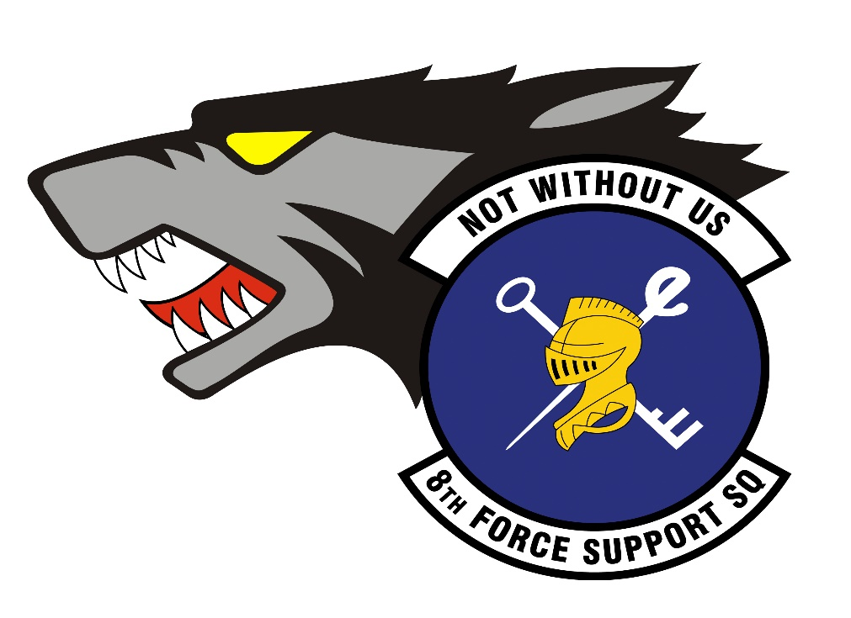
8 FSS/FSPS Customer Support
Hours of Operation & Contact Information

Customer Service Hours:
Monday-Friday 0800-1500
Closed during holidays & Wing Training Days (3rd Thursday of the Month)
Telephone:
DSN: 315-782-8377, option 1
Commercial: 001-82-063-470-8377, option 1
Org Box:
8fss.mps@us.af.mil
Understanding Command Sponsorship Program (CSP)
Command Sponsorship allows a service member to bring their dependents to their overseas duty station. This program allows a limited number of positions to serve a 2-year accompanied tour, based on installation support capacity. Once sponsored, dependents are authorized access to base facilities, and the service member becomes eligible for allowances to help cover the cost of living with their family.
All personnel projected to PCS to Kunsan AB and its supported units can apply for Command Sponsorship if they meet the requirements in AFI 36-2110, 7.11.2. Sponsorship becomes effective on the date the Wing Commander approves it.
The Application Process
Please be aware that Command Sponsorship packages may take 2-3 weeks for review and final approval. Incomplete or incorrect documents may cause a delay in processing time.
To submit a CSP application request, please follow the steps below:
- Read & Adhere to the guide & fill out “Kunsan AB – Initial CSP Application Form”
- Complete 8 FSS’ CSP Survey: 8 FSS CSP Survey & upload initial required documents
- Initial Required Documents:
- Initial CSP Application Form
- Current AMS SURF
- DD Form 1172-2
- Complete DAF Form 965
After CSP approval, email Final Required Documents to: 8 FSS/FSPS Customer Support
- Final Required Documents:
- PCS Orders (DAF Form 899) & Amendments (AF IMT 973-if applicable)
- KAIP Declination Agreement (CSP disqualifies members from KAIP)
- NEO Memorandum
- Concurrent Travel Memo
- EFMP Family Member’s Medical Clearance for Travel - AF Form 1466

