Kunsan Air Base
Command Sponsorship Guide
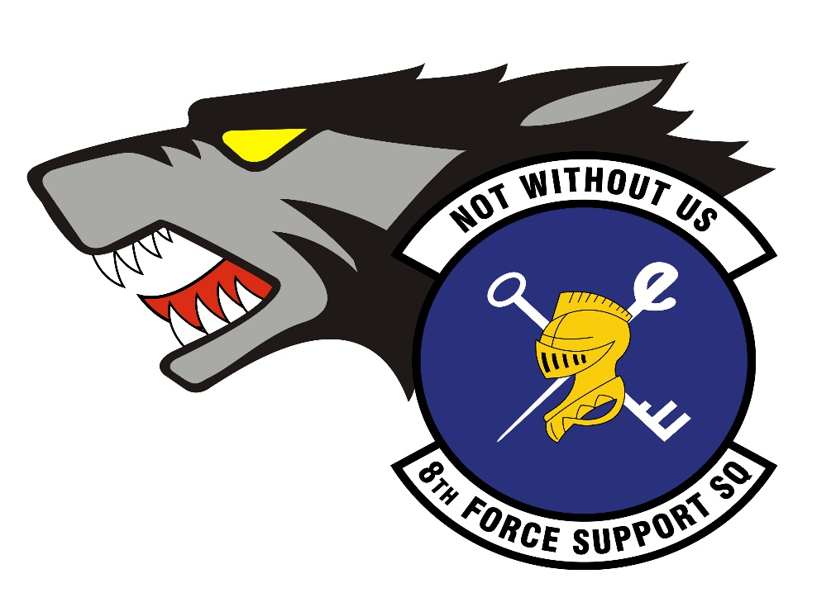
8 FSS/FSPS Customer Support
Hours of Operation & Contact Information

Customer Service Hours:
Monday-Friday 0800-1500
Closed during holidays & Wing Training Days (3rd Thursday of the Month)
Telephone:
DSN: 315-782-8377, option 1
Commercial: 001-82-063-470-8377, option 1
Org Box:
8fss.mps@us.af.mil
Understanding Command Sponsorship Program (CSP)
Command Sponsorship allows a service member to bring their dependents to their overseas duty station. This program allows a limited number of positions to serve a 2-year accompanied tour, based on installation support capacity. Once sponsored, dependents are authorized access to base facilities, and the service member becomes eligible for allowances to help cover the cost of living with their family.
All personnel projected to PCS to Kunsan AB and its supported units can apply for Command Sponsorship if they meet the requirements in AFI 36-2110, 7.11.2. Sponsorship becomes effective on the date the Wing Commander approves it.
The Application Process
Please be aware that Command Sponsorship packages may take 2-3 weeks for review and final approval. Incomplete or incorrect documents may cause a delay in processing time.
To submit a CSP application request, please follow the steps below:
- Read & Adhere to the guide & fill out “Kunsan AB – Initial CSP Application Form”
- Complete 8 FSS’ CSP Survey: 8 FSS CSP Survey & upload initial required documents
- Initial Required Documents:
- Completed Initial CSP Application Form
- Current AMS SURF
- DD Form 1172-2 (No PO Box as address)
- EFMP/Family Member’s Medical Clearance for Travel (FMTS screenshot)
- Kunsan Assignment RIP
After CSP approval, email Final Required Documents to: 8 FSS/FSPS Customer Support
- Final Required Documents:
- PCS Orders (DAF Form 899) & Amendments (AF IMT 973-if applicable)
- KAIP Agreement Memo
- NEO Memorandum
- Concurrent Travel Memo
- Completed DAF Form 965

Kunsan Air Base Command Sponsorship Program
Quick Reference Sheet
Current as of 23 Mar 2026

Bottom Line Up Front: Kunsan Air Base is executing a phased, mission-prioritized shift toward Korea tour normalization by establishing an initial Command Sponsorship Program (CSP) capacity in FY26.

Strategic Context: USFK “3-2-1” Tour Normalization
USFK’s Korea “3-2-1” model standardizes tours to improve operational continuity and quality of life:
- 36 months accompanied tours (with dependents)
- 24 months unaccompanied tours
- 12 months only as an exception when an accompanied tour is requested but cannot be supported due to constraints (e.g., housing/mission/support capacity)
Kunsan is implementing a CSP tour model:
- 24 months accompanied tours with approved CSP
- 12 months unaccompanied tours and those with dependents who don’t apply or aren’t approved for CSP

What Kunsan Has Already Done (Key Decisions & Authorities)
- USFK approval to initiate CSP at Kunsan: Under CSP, Kunsan will adopt 2-year accompanied tours.
- Initial CSP capacity: 20 CSP billets approved by USFK/J1 starting in 2026.
- Program management: 8 FSS/MPF manages CSP billets in coordination with the 7 AF CSP Management Authority.

How Kunsan Is Implementing CSP (Phased, Mission-Prioritized)
1) Start small, scale deliberately:
- CSP billets deliberately match & will change commensurate with dependent support capacity and mission requirements
2) Prioritize mission-critical leadership and continuity:
- The 8 FW/CC approved a Command Sponsored Prioritization List (CSPL) comprised of 44 officer and senior enlisted positions, essential to mission execution and U.S. presence. These billets have fill-first priority. Members not filling a CSPL position need to be concurred by the gaining Sq/CC and then approved by the 8 FW/CC at Kunsan in addition to securing clearance for dependent travel.
- All members interested in command sponsorship must apply, regardless of CSPL priority. If approved, they will serve a 2-year accompanied Long Tour; if they do not apply for or are denied command sponsorship, they will serve a 1-year unaccompanied Short Tour.
3) Direct tie to readiness outcomes:
- 7 AF and 8 FW frame Kunsan’s CSP as improving operational effectiveness, mission continuity, and family resiliency, while advancing peninsula-wide tour normalization.

Installation Support Reality (What Kunsan Can Support Today)
Kunsan’s CSP is designed to leverage local community capacity, key constraints and mitigation factors:
Housing
- No on-base family housing; all dependent housing is off-base and on the economy (apartment-style). The 8 CES Housing Office provides support in finding available housing and coordinating with local realtors.
- Local Renter Policy: Off-base predominantly require a full-years’ worth if rent up front.
Childcare
- No U.S. Child Development Center
- Per Korean Law, there are no child care services off base for children 0 – 1 year of age.
- ROKAF childcare is available first-come, first-served with capacity to support ~12–30 U.S. children (capacity-dependent). Off-base childcare options are on the economy and personally procured without base support/coordination.

Education
- No on-base schools.
- Off-base international school option supports up to ~40 children (capacity-dependent); boarding school options exist in major cities; standardized testing (SAT/ACT/PSAT) available via DoDEA sites at Osan AB/Camp Humphreys.
- Dependent schooling will be subsidized by the NDSP, so families will not have out-of-pocket expenses for off-base schooling.
- No special education services currently available.
Medical
- Dependents receive care off-base; limited local primary care specialties are identified (e.g., Family Medicine, Internal Medicine, Pediatrics).
- Dependents enroll in TRICARE Overseas Select; deductibles/copays apply for host-nation care.
Personal Operated Vehicle (POV)
- As an exception to Kunsan AB Community Standards, personnel and their dependents, under the Kunsan AB CSP, will be allowed to own and operate a vehicle on the installation.
Pets
- Kunsan does not currently have any on base veterinary or pet quarantine capabilities, so members will need to utilize off base veterinary care
- For pets traveling from the United States to Korea, families should refer to the APHIS Pet Travel website where it outlines the most up to date requirements for pets to enter Korea.
  - https://www.aphis.usda.gov/pet-travel/us-to-another-country-export/pet-travel-us-korea
- Service members with access to a military VTF will be able to receive all the necessary documentation; but ultimately it is the responsibility of the pet owner to ensure all documentation and pet travel requirements are met. Please be advised that FAVN results typically take 6 to 8 weeks for results to return, so SM should plan well in advance their pet’s travel requirements prior to PCSing to avoid extended quarantine.
- Non-Combatant Evacuee Operations (NEO) have a limit of 2 pets per family in the event of an evacuation. Only dogs and cats are allowed to be transported in a NEO.

Why This Matters to the Air Force (Operational Payoff)
This CSP implementation is a near-term mechanism to deliver the intended effects of tour normalization:
- Stabilizes key leadership and mission-critical billets by reducing turnover and training churn.
- Improves unit continuity and readiness through longer on-station expertise accumulation.
- Strengthens resiliency for members and families where support is feasible, while maintaining an exception pathway when it is not.

Note: Korea Assignment Incentive Pay (KAIP) is still available as a means to a 2-year tour, while bringing dependents in a non-CSP capacity. An Airman filling a CSP slot does not qualify for KAIP, however, they will earn an increase in household goods allowance, funded dependent travel, prioritized dependent support and education funding for school-age children. Mil to Mil couples with no dependents should NOT apply for CSP. If you are interested in a 2-year tour and fall into that category, please apply for KAIP.

